**Q. Write a program in assembly language to print “Hello World”.**

CODE:

org 100h

jmp start

msg: db "Hello World!", 0Dh,0Ah, 24h

start: mov dx, msg

mov ah, 09h

int 21h

mov ah, 0

int 16h

ret

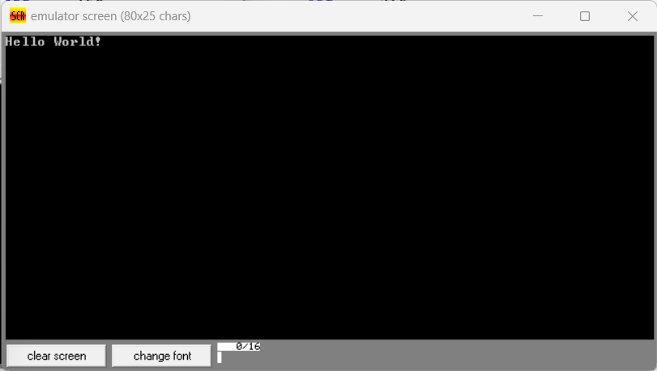

**Q. Write an assembly language program to print your name.**

org 100h

jmp start

msg: db "Sruthi!", 0Dh,0Ah, 24h

start: mov dx, msg

mov ah, 09h

int 21h

mov ah, 0

int 16h

ret

